OODP workshop 4

**Submitted by**

**Sabbir Hasan Rabbi**

**Id: k240175**

1. **What are different types of loops in java? Explain each of them with proper syntax.**

In java there are mainly 3 types if loops. These are:

**while loop**

The while loop is a **pretest loop**. It is used when we want to repeat a block of code as long as a condition is true. It checks the condition before executing the loop's body.

**Syntax:**

while (condition) {

*// code block to be executed*

}

**Explanation:**

* The loop continues to execute as long as the condition is true.

**do-while Loop**

The do-while loop is **similar to the while loop**, but the condition is checked after the loop has executed. This means the loop will always execute at least once. Hence it is a **post test loop**.

**Syntax:**

do {

*// code block to be executed*

} while (condition);

**Explanation:**

* The loop executes the code block first and then checks the condition. If the condition is true, it repeats the loop.

**for loop**

The for loop is used when it is known in advance that how many times we want to execute a statement or a block of statements. It is **counter controlled** loop.

**Syntax:**

for (initialization; condition; update) {

*// code block to be executed*

}

**Explanation:**

* Initialization: Initializes a counter variable.
* Update: This is executed after each iteration of the oop.

1. **Write a program to ask the user to enter a number and print count down from that number to 0.**

**The java program:**

import java**.**util**.**Scanner;

**public** **class** countdown {

**public** **static** **void** main(String[] args) {

**int** n;

        System.out.println("ENTER THE NUMBER");

        Scanner s=new Scanner(System.in);

        n=s.nextInt();

        while(n!=-1)

        {

            System.out.println(n);

            n--;

        }

        System.out.println("END OF COUNTDOWN");

    }

}

**The output for 5 as an input :**

1. **Write a program to ask user to enter the temperature of seven days and then find out the average temperature and print the results.**

the java program for the given question:

import java**.**util**.**Scanner;

**public** **class** AverageTemperature {

**public** **static** **void** main(**String**[] args) {

        Scanner scanner = new Scanner(System.in);

**int** day = 1;

**double** totalTemperature = 0;

        do {

            System.out.print("Enter the temperature for day " + day + ": ");

**double** temperature = scanner.nextDouble();

            totalTemperature += temperature;

            day++;

        } while (day <= 7);

**double** averageTemperature = totalTemperature / 7;

        System.out.println("The average temperature over 7 days is: " + averageTemperature);

    }

}

The output for 7 days random input

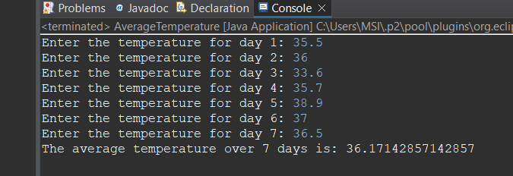

1. **Write a program to ask user a value and make sure that value is between 3 and 6 inclusive. Keep asking the user until user enters a valid value and display a success message and print error when user enter invalid value.**

**The java code is given below for the problem.**

// here I used while loop

import java**.**util**.**Scanner;

**public** **class** ValueChecker {

**public** **static** **void** main(String[] args) {

        Scanner scanner = new Scanner(System.in);

**int** value;

        System.out.print("Enter a value between 3 and 6: ");

        while (true) {

            value = scanner.nextInt();

            if (value >= 3 && value <= 6) {

                System.out.println("Success! You entered a valid value.");

                break;

                   }

            else {

                System.out.println("Error: Invalid value. Please try again.");

            }

        }

    }

}

The output will be like

